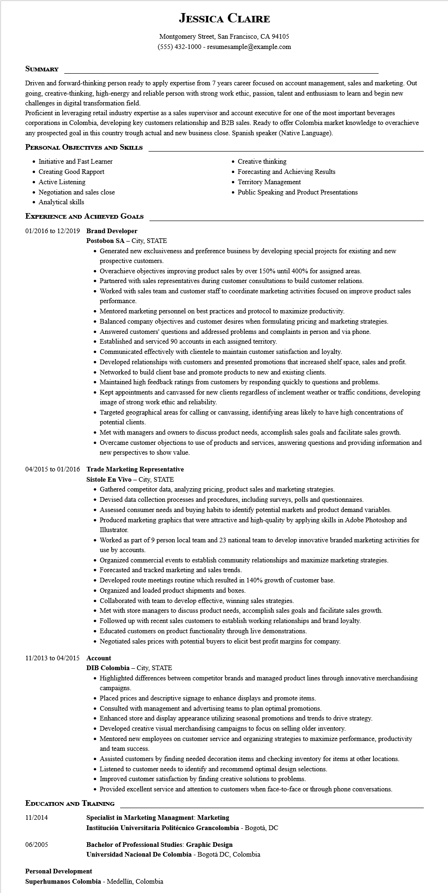
JESSICA CLAIRE
Montgomery Street, San Francisco, CA 94105
(555) 432-1000 - resumesample@example.com
SUMMARY
Driven and forward-thinking person ready to apply expertise from 7 years career focused on account management, sales and marketing. Out going, creative-thinking, high-energy and reliable person with strong work ethic, passion, talent and enthusiasm to learn and begin new challenges in digital transformation field.
Proficient in leveraging retail industry expertise as a sales supervisor and account executive for one of the most important beverages corporations in Colombia, developing key customers relationship and B2B sales. Ready to offer Colombia market knowledge to overachieve any prospected goal in this country trough actual and new business close. Spanish speaker (Native Language).
PERSONAL OBJECTIVES AND SKILLS
• Initiative and Fast Learner
• Creating Good Rapport
• Active Listening
• Negotiation and sales close
• Analytical skills
EXPERIENCE AND ACHIEVED GOALS
01/2016 to 12/2019 Brand Developer Postobon SA - City, STATE
• Creative thinking
• Forecasting and Achieving Results
• Territory Management
• Public Speaking and Product Presentations
• Generated new exclusiveness and preference business by developing special projects for existing and new prospective customers.
• Overachieve objectives improving product sales by over 150% until 400% for assigned areas.
• Partnered with sales representatives during customer consultations to build customer relations.
• Worked with sales team and customer staff to coordinate marketing activities focused on improve product sales performance.
• Mentored marketing personnel on best practices and protocol to maximize productivity.
• Balanced company objectives and customer desires when formulating pricing and marketing strategies.
• Answered customers' questions and addressed problems and complaints in person and via phone.
• Established and serviced 90 accounts in each assigned territory.
• Communicated effectively with clientele to maintain customer satisfaction and loyalty.
• Developed relationships with customers and presented promotions that increased shelf space, sales and profit.
• Networked to build client base and promote products to new and existing clients.
• Maintained high feedback ratings from customers by responding quickly to questions and problems.
• Kept appointments and canvassed for new clients regardless of inclement weather or traffic conditions, developing image of strong work ethic and reliability.
• Targeted geographical areas for calling or canvassing, identifying areas likely to have high concentrations of potential clients.
• Met with managers and owners to discuss product needs, accomplish sales goals and facilitate sales growth.
• Overcame customer objections to use of products and services, answering questions and providing information and new perspectives to show value.
04/2015 to 01/2016 Trade Marketing Representative
Sistole En Vivo - City, STATE
• Gathered competitor data, analyzing pricing, product sales and marketing strategies.
• Devised data collection processes and procedures, including surveys, polls and questionnaires.
• Assessed consumer needs and buying habits to identify potential markets and product demand variables.
• Produced marketing graphics that were attractive and high-quality by applying skills in Adobe Photoshop and Illustrator.
• Worked as part of 9 person local team and 23 national team to develop innovative branded marketing activities for use by accounts.
• Organized commercial events to establish community relationships and maximize marketing strategies.
• Forecasted and tracked marketing and sales trends.
• Developed route meetings routine which resulted in 140% growth of customer base.
• Organized and loaded product shipments and boxes.
• Collaborated with team to develop effective, winning sales strategies.
• Met with store managers to discuss product needs, accomplish sales goals and facilitate sales growth.
• Followed up with recent sales customers to establish working relationships and brand loyalty.
• Educated customers on product functionality through live demonstrations.
• Negotiated sales prices with potential buyers to elicit best profit margins for company.
11/2013 to 04/2015 Account
DIB Colombia - City, STATE
• Highlighted differences between competitor brands and managed product lines through innovative merchandising campaigns.
• Placed prices and descriptive signage to enhance displays and promote items.
• Consulted with management and advertising teams to plan optimal promotions.
• Enhanced store and display appearance utilizing seasonal promotions and trends to drive strategy.
• Developed creative visual merchandising campaigns to focus on selling older inventory.
• Mentored new employees on customer service and organizing strategies to maximize performance, productivity and team success.
• Assisted customers by finding needed decoration items and checking inventory for items at other locations.
• Listened to customer needs to identify and recommend optimal design selections.
• Improved customer satisfaction by finding creative solutions to problems.
• Provided excellent service and attention to customers when face-to-face or through phone conversations.
EDUCATION AND TRAINING
11/2014
06/2005
Specialist in Marketing Managment: Marketing
Institución Universitaria Politécnico Grancolombia - Bogotá, DC
Bachelor of Professional Studies: Graphic Design
Universidad Nacional De Colombia - Bogotá DC, Colombia
Personal Development
Superhumanos Colombia - Medellín, Colombia

